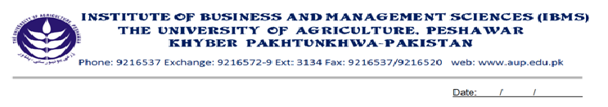

Programme: BS (IT)-V
Course Name: Computer Communication & Networks
Course Code: IT-503
Credit Hours: 03
Course Week: 16
Total Hours: 48

Course Objectives
To introduce students to the concept of computer communication, Analogue and Digital Transmission, Network Layers, Network models (OSI & TCP/IP) and Protocol standards. Emphasis is given on the understanding of modern network concepts.

Week-1
-Introduction
- Data Communication Components
- Networks
- Protocol & Standards

Week-2
- Basic Concepts
- Line Configuration
- Topology
- Transmission mode

Week-3
- Categories of Networks
- Key Terms & Concepts
- Local Area Network (LAN)
- Wide Area Network (WAN)
- Wireless Network

Week-4
- The OSI Model
- Layered Architecture
- Functions of the Layers

Week-5
- Transmission Control Protocol/Internet Protocol
- TCP/IP Protocol Suite
- Functions of the layers
- Routing & Bridging

Week-6
- Application Protocol and TCP/IP utilities
- Telnet & file Transfer Protocol
- IP Utilities and addressing

Week-7
- Analog and Digital (Signal)
- Analog and Digital Data
- Analog and Digital Signal
- Time & Frequency Domain

Week-8
- Digital Transmission Fundamentals
- Digital Representation of Information
- Characterization of Communication Channels
- Fundamental Limits in Digital Transmission
- The Nyquist Signaling Rate
- The Shannon Channel Capacity

Week-9
- Encoding
- Digital-to-Digital Conversion
- Analog to Digital Conversion
- Digital to Analog Conversion
Week-10
- Transmission of Digital Data: (Interfaces)
- Digital Data Transmission
- DTE-DCE Interface
- Other Interface Standards
Week-11
- Transmission Media
- Noise, Attenuation & Decibel
- Guided Media
- Unguided Media

Week-12
- Transmission System and Multiplexing
- Frequency Division Multiplexing
- Time Division Multiplexing
- Wave Length Division Multiplexing plus DWDM
- Digital Subscriber Line

Week- 13
- Error Detection & Correction
- Types of errors & Detection
- Cyclic Redundancy Check
- Checksum & Error Correction
- Flow Control and error Control

Week-14
- Data Link Control Protocols
- Asynchronous Protocol
- Synchronous Protocol
- Bit Oriented Protocol

Week-15
- ATM Network
- ATM Layer & Service Categories
- ATM Signaling

Week-16
- Approaches to Network Design
- The Internet&Packet Switching
- Telephone Networks & Circuit Switching
- Telegraph Network & Message Switching

Recommended Books:
- Data & Computer Communication by Behrouz
- Communication Networks by Leon Garcia & Widjaja

