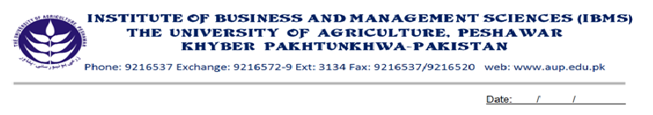
Program: BS (IT)-V
Course Title: Marketing
Course Code: MG-501
Course Hours: 03
Total Week: 16
Total Credit Hours: 48

Course Objective
This course aims at giving an overall view of the field of marketing on the basis of basic concepts like fours P’s, various functions and institutions of marketing and the different kinds of problems in marketing that the modern decision maker must resolve.

Week 1
Marketing, Market, Emarketing.
Evolution of Marketing.
The Marketing Mix.
Internal and External Environment
Controllable Factors in Marketing.
Uncontrollable Factors in Marketing.
Week 2
Target Marketing.
Guidelines in Selecting the Target Market.
Market Segmentation.
Week 3
Types of Buyers.
Ultimate Consumers.
Business and Organizational Buyers.
Consumer Buying or Purchasing Process.
Week 4
The Product.
The Consumer Products.
The Business Products.
Classifications of the Consumer Products.
Classifications of the Business Products.

Week 5
Product Innovation.
Importance of the Product Innovation.
Categories of the New Product.
Stages in Developing the New Product.

Stages in the Adoption Process.
Organizing for the Product Innovation.
Week 6

Branding.
Classification of Brands on the Basis of Ownership
Branding in the Basis of Coverage.
Characteristics of Good Brand Name.
Generic Brands and How to Protect Them.

Week 7 Labeling, Types of Labels, Packaging

Week 8 Benefits/Importance of Packaging, Family and Multi Packaging.
Criticism on Packaging

Week 9
Product
The Pricing, the Importance of Pricing
The Pricing Objectives, Setting the Price
Discounts and Allowances, Geographic Pricing Strategies
Week 10
Distribution
The Distribution, Middlemen and Distribution Channels, Important Classes of Middlemen
Channels for Consumer Goods, Channels for the Business Goods
Week 11
Distribution of Services
Factors Affecting the Choice of Channels
Retailers, Classification of Retailers
Tasks in the Physical Distribution Management
Week 12
Promotion
The Promotion Strategies
The Promotion Mix

Week 13 Developing an Advertising Campaign

Week 14 Personal Selling, Publicity, Sales Promotion

Week 15 Current Issues in Marketing

Week 16 Revision, Case Study, Group Discussion.

Text Book:

1. PRINCIPLES OF MARKETING --- Phillip Kotler, Gary Armstrong, 7th Edition Prentice Hall Publishers-2000.

Recommended Books:

1. PRINCIPLES OF MARKETING by Michael J.Etzel, Brvce J.Walker William J.Stanton 11th Edition McGraw Hill-1997.
2. PRINCIPLES OF MARKETING: Thomas C. Kinnear, Kenneth L-Bern Hardt,
4thEdition Kathleem A.Krentler, Honper Collin College Publishers.
3. MARKETING --- Joel R.Evans, Barry Bevnan, 4th Edition. Mc Millian Publisher.
4. MARKETING: William M.Pride .O.C. Ferrell 6thEdition, Hovghton Mifflin CO.1989.

